1. Labeled diagram of an ATX motherboard
An ATX motherboard is the main circuit board of a desktop computer. It connects the processor, memory, storage devices, graphics card, power supply, and external peripherals.
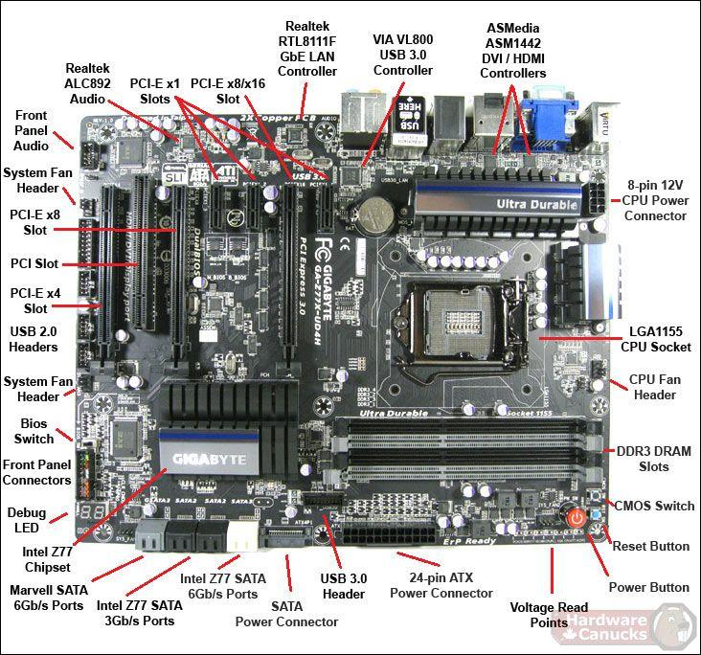
Important slots and ports
- CPU socket — holds the processor.
- RAM (DIMM) slots — hold memory modules.
- PCIe x16 slot — connects a graphics card.
- PCIe x1 slots — support expansion cards.
- SATA ports — connect HDDs and SATA SSDs.
- 24-pin ATX connector — supplies power to the motherboard.
- 8-pin CPU power connector — supplies power to the processor's power circuitry.
- USB headers — connect front-panel USB ports.
- Rear USB ports — connect keyboards, mice, and other USB devices.
- Ethernet (LAN) port — connects to a wired network.
- Audio jacks — connect speakers, headphones, and microphones.
- CMOS battery — helps maintain the real-time clock and firmware settings.
Conclusion: The motherboard provides the physical connections and communication pathways that allow all computer components to work together.

2. Three popular CPU socket types and compatible processors
A CPU socket is the connector on the motherboard where the processor is installed. The processor and motherboard must have compatible sockets and platform support.
CPU socket | Compatible CPU example | Manufacturer
LGA1151 | Intel Core i7-6700K | Intel    Intel  +1
AM4 | AMD Ryzen 5 5600X | AMD  AMD
LGA1200 | Intel Core i5-10400F | Intel  Intel
Important: A matching socket alone does not guarantee compatibility. The motherboard chipset, BIOS version, and processor generation must also be supported.

3. Functions of the CPU and chipset

CPU (Central Processing Unit)
The CPU is often called the brain of the computer. Its main functions are:
- Processing instructions: Executes instructions from programs and the operating system.
- Performing calculations: Handles arithmetic and logical operations.
- Managing tasks: Runs application code and coordinates computing work.
- Working with memory: Reads and processes the instructions and data needed by programs.

Chipset
The chipset helps manage communication between the CPU and various motherboard components. Depending on the motherboard design, it supports connectivity for devices such as USB ports, SATA storage, networking, and additional PCIe devices.
- Device communication: Helps connected hardware exchange data.
- Connectivity: Provides or manages interfaces for USB, storage, and expansion devices.
- Data coordination: Helps route communication between supported components and the processor.
Modern systems also have direct CPU connections to important components, such as RAM and some PCIe devices, so not every data transfer passes through the chipset.

Example: What happens when you open Spotify?
Step 1 — You click Spotify
The operating system receives your click and schedules the application to run.
Step 2 — The CPU processes instructions
The CPU executes Spotify's program instructions and performs the calculations needed to start the app.
Step 3 — Program data is accessed
The system reads the required files from storage and loads program data into RAM. The CPU communicates with memory and storage through the relevant hardware interfaces.
Step 4 — The chipset and interfaces help connect devices
Network and other hardware interfaces enable communication with the internet and connected devices. Spotify can then retrieve music data from its servers.
Step 5 — Music plays
The CPU and audio hardware work together to process and play the audio through your speakers or headphones.
In simple words: The CPU does the computing, while the chipset helps provide and coordinate connections to many of the devices the computer uses. Together with RAM, storage, networking, and audio hardware, they allow Spotify to open and play music.

4. Real motherboard photo with at least five labeled components
Use the manufacturer's official product gallery for a real motherboard photograph: MSI B450 TOMAHAWK MAX — official photo gallery. The manufacturer's specifications confirm the board's AM4 CPU socket, four DIMM memory slots, PCIe slots, SATA connectors, and internal power connectors.

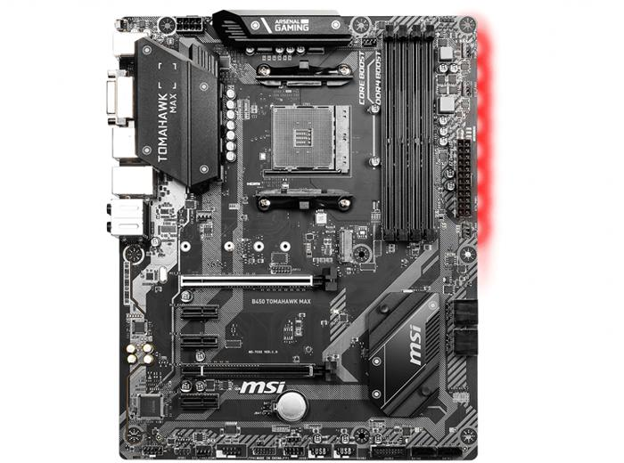
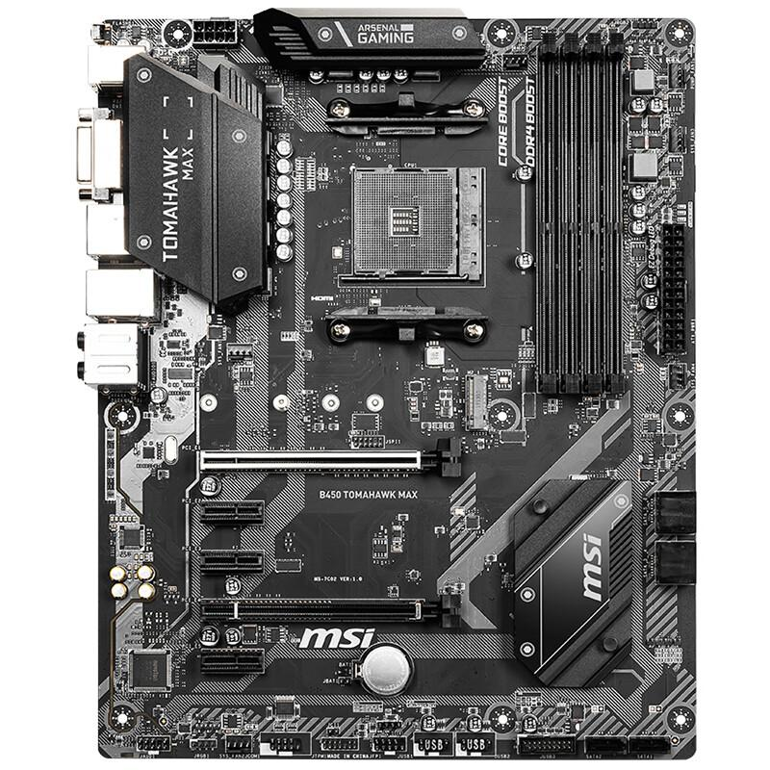
1. CPU socket (AM4)
Near the upper-middle area of the board.
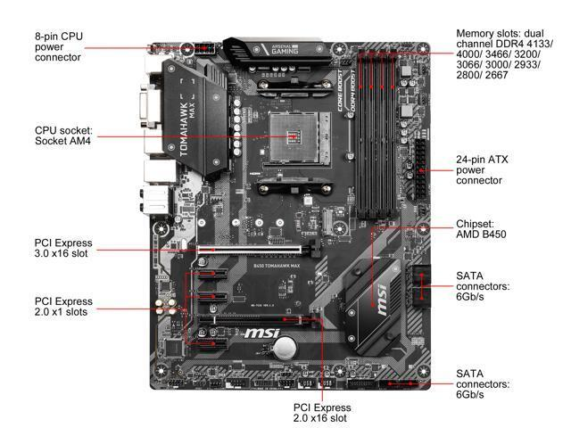
2. RAM slots (DIMM)
Four long slots along the right side of the CPU socket.
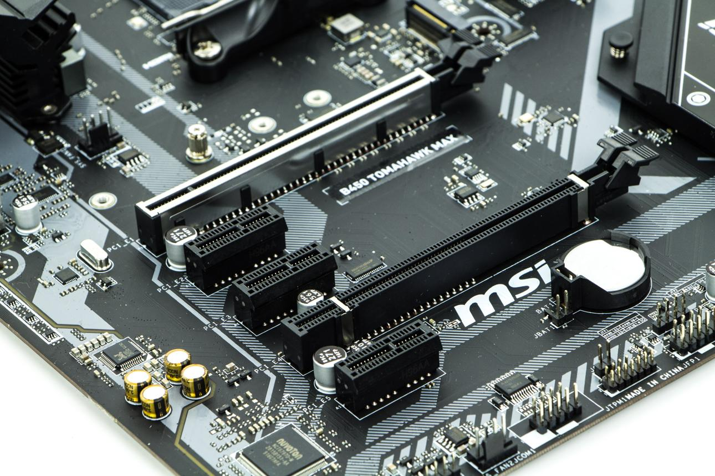
3. PCIe x16 slot
A long expansion slot used primarily for a graphics card.
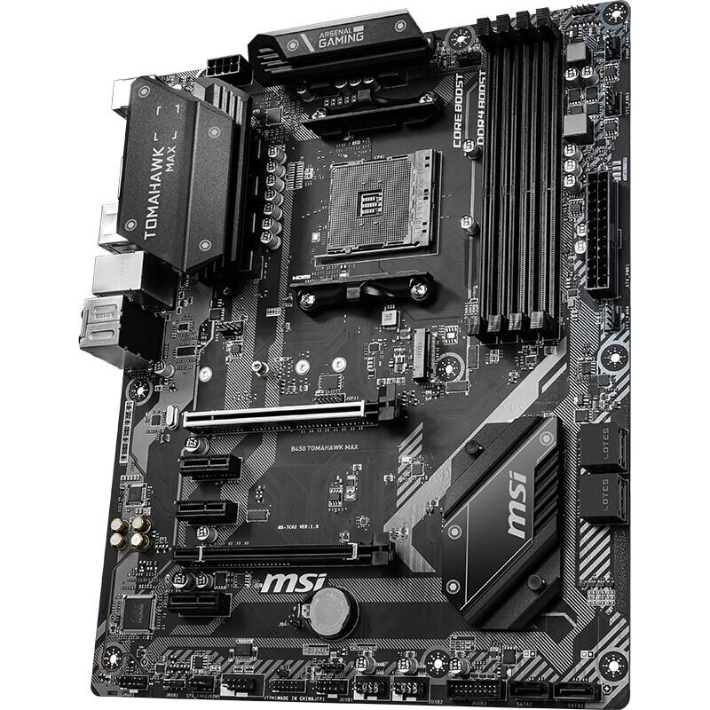
4. SATA ports
Located near the board's right edge; used for SATA drives.
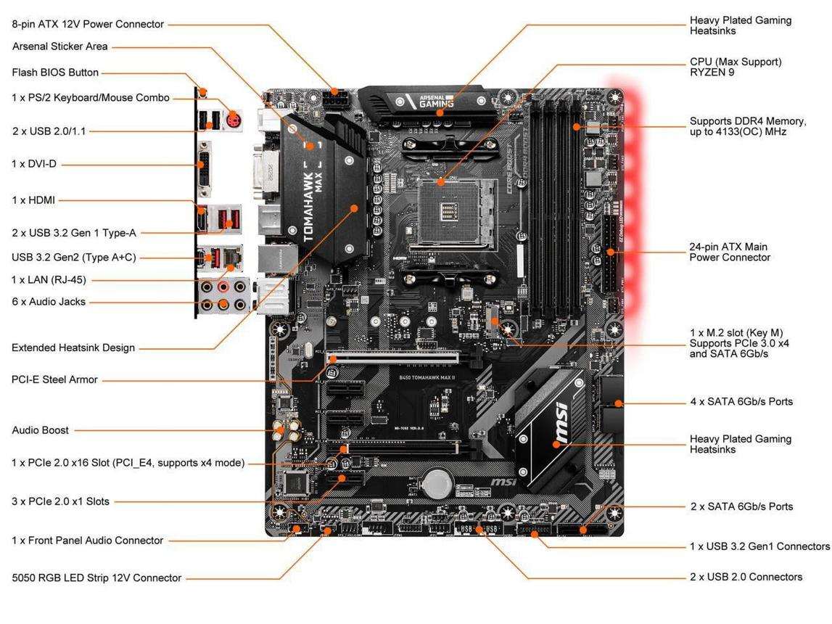
5. 24-pin ATX power connector
Along the right edge of the board; connects the main power supply cable.

